“Channel shift – evaluating Mosaic personas as a tool in improving web forms”

Table of Contents

1 Introduction 2

1.1 Context 3

1.2 Objective of the project 3

1.3 Thesis structure 3

2 Background 4

2.1 The role of design 4

2.2 Data-driven design 4

2.2.1 Data-driven design methods 4

2.2.2 Business Intelligence 4

2.3 Human-driven design 4

3 Description of the work undertaken 6

3.1 CRM data 6

3.2 Mosaic data 6

3.3 IBM Cognos 6

3.4 Preliminary activities 7

3.4.1 Meetings in the Council 7

3.4.2 First iteration (proof-of-concept) 7

3.4.3 Problems 21

3.5 Work undertaken 22

4 Analysis or Evaluation 23

5 Conclusion 23

6 Bibliography 23

# Introduction

an introduction to the document, clearing stating the hypothesis or objective of the project, motivation for the work and the results achieved. The structure of the remainder of the document should also be outlined.

Over the last few years, the School of Informatics has been collaborating with the City of Edinburgh Council in the area of open data in initiatives such as the Smart Data Hack and the Council's EdinburghApps hackathons. In the context of Edinburgh Living Lab, this relationship has broadened into investigating other areas of data science, and new kinds of collaboration. My MSc project is taking place within this context, and is focussing on bringing analytic techniques to bear on Customer Relationship Management (CRM) data that has been collected by the Council over the last year.

As one of fastest growing local authority areas in Scotland, Edinburgh is facing an ever increasing demand for Council services, outstripping the funds available to meet this demand. There are a number of projects on-going in the Council that try to address the resulting challenges, one of which aims to improve the way that Council interacts with residents, particularly in terms of dealing with complaints and reports of problems. At the moment, citizens can communicate with the Council using multiple 'channels': email, web forms, mobile apps, phone, post and face-to-face conversation. So-called "channel shift" is the policy of encouraging residents to use web forms in preference to other communication channels. In order to promote channel-shift, the Council is exploring a number of ideas, which are being developed across two distinct units, namely digital services and business intelligence. The Council has been recently building capacity to collect data and use sophisticated tools for managing and integrating it. My MSc project is hoping to contribute to internal resources for extracting business insights from analysing this data.

At this stage of the project, I have managed to carry out a few proof-of-concept analyses. One of these focused on a specific set of interactions, namely reports by residents of missed bin collections. One interesting question is whether there are patterns in what kind of people reports such problems and whereabouts in the city they are located. The Council uses the notion of 'user persona' to group residents into a number of categories, based on a combination of indicators including demographics, lifestyles, preferences and behaviour, drawing on data such as the Census, the Electoral Roll, house sale prices, and the ONS annual Expenditure and Family Survey. By combining CRM data with these personas, I was able to make clear who are primary users of the 'missed bin collection' reporting service, relative to each channel.

I am currently investigating a couple of further issues. One of those include cases where users tried using a web form, but for some reason switched to face-to-face or phone channel instead.

More broadly, I hope that my research will help the Council to ensure that transactions initiated via digital channels are dealt with effectively, as well as contributing to creating “success stories” and know-how within the Council for implementing transactions for services which do not yet support digital channels.

## Context

* Context objective: the Council has personas based on Mosaic data, but it is unclear if they would be helpful for designing web forms
* Use BI tools and design practices in the process
* Work with CRM data and IBM Cognos

## Objective of the project

* evaluate usefulness of Mosaic personas in improving web forms

## Thesis structure

# Background

background to the project, previous work, exposition of relevant literature, setting of the work in the proper context. This should contain sufficient information to allow the reader to appreciate the contribution you have made.

## The role of design

## Data-driven design

### Data-driven design methods

### Business Intelligence

#### Introduction to Business Intelligence

#### Review of recent works

#### Business Intelligence and User Centered Design

#### Architecture

#### Data analysis in Business Intelligence

#### Structured and Unstructured data

(Baars & Kemper 2008)

## Human-driven design

#### Introduction to “anthropological” design

#### User Centered Design

#### Review of recent works

#### Tools and practices

Design tools that could be used:

* Ethnographical methods
  + Interviews/surveys
  + …
* Usability inspection methods (as early as possible):
  + Heuristic evaluation
  + cognitive walkthroughs
* Usability testing methods (later on, after some ground was established):
  + Qualitative
    - In-person testing (so-called hallway testing)
    - Remote testing
  + Quantitative
    - comparison test (a-b testing)
    - Success rate
    - task scenarios
* prototypes
  + “low-fidelity” – as early as possible
  + “high-fidelity” – later on, after some ground was established
* participatory workshop (focus group)
* Think a-loud technique
* personas
* hackathon

Analytical tools:

* 5 why model
* Swot analysis
* Cost-benefit evaluation
* QUPER model

# Description of the work undertaken

this may be divided into chapters describing the conceptual design work and the actual implementation separately. Any problems or difficulties and the suggested solutions should be mentioned. Alternative solutions and their evaluation should also be included.

## CRM data

Its properties, etc.

For unregistered users there is an assumption about the postcode that they are close to home.

CRM documentation

- system description RightNow (Oracle CRM)

- description of the project in the Council, what stage they are at

CRM data documentation

- what information is collected

## Mosaic data

Mosaic documentation

- sources of data

- viability (accuracy)

- Structure of data

- How you can process

## IBM Cognos

Web access point: IBM Cognos Connection, http://c-cog-dev-app-1/ibmcognos/

IBM Cognos help center: http://pic.dhe.ibm.com/infocenter/cogic/v1r0m0/index.jsp

IBM Cognos connection 10.2.1

google: ibm Business Intelligence Getting Started Guide

knowledge centre: http://www-01.ibm.com/support/knowledgecenter/#!/

IBM Cognos Report Studio

workflow (cognos report studio guide, page 56):

Type of report you want to generate: Do you think about your data as a set of tables (relational) or a number of dimensions intersecting at cells (dimensional)

## Preliminary activities

### Meetings in the Council

* I developed a list of things that I could do
* Sally suggested a specific topic (personas and CRM)

### First iteration (proof-of-concept)

Proof of concept (first iteration, working with Kevin to see if it's even possible)

- we quickly exported some data from the CRM system

- tried to link it with Mosaic package

- failed

- I then got access to all the systems, I wanted to document what we tried to do and move on to other solutions (e.g. importing both datasets to MS Access, setting up a local database and populating it with the data , MS Excel, use Python scripts)

- I managed to solve the problem - create a new package

- played a bit creating reports

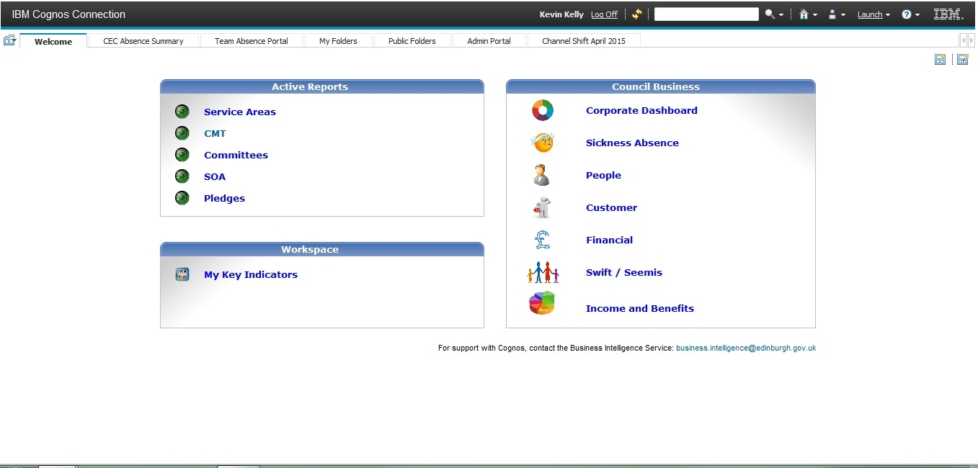

Figure 1 Welcome page of IBM Cognos Connection (web interface to the entire package)

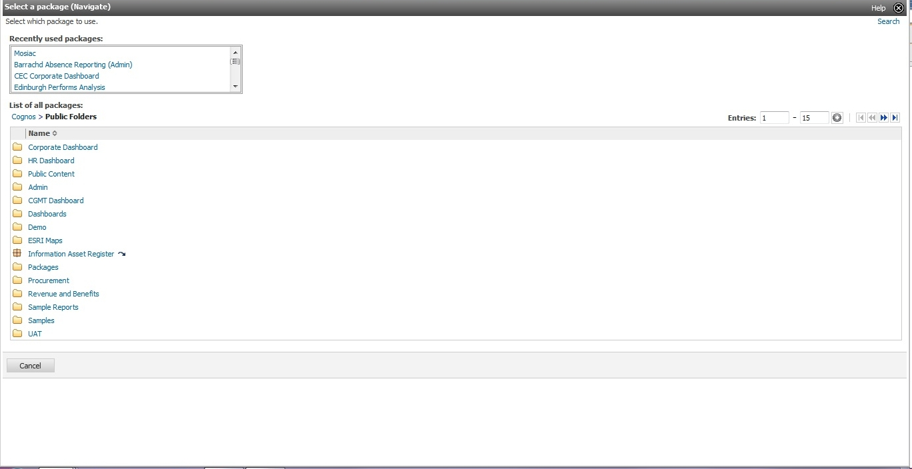

Figure 2 Select data package for Report Studio

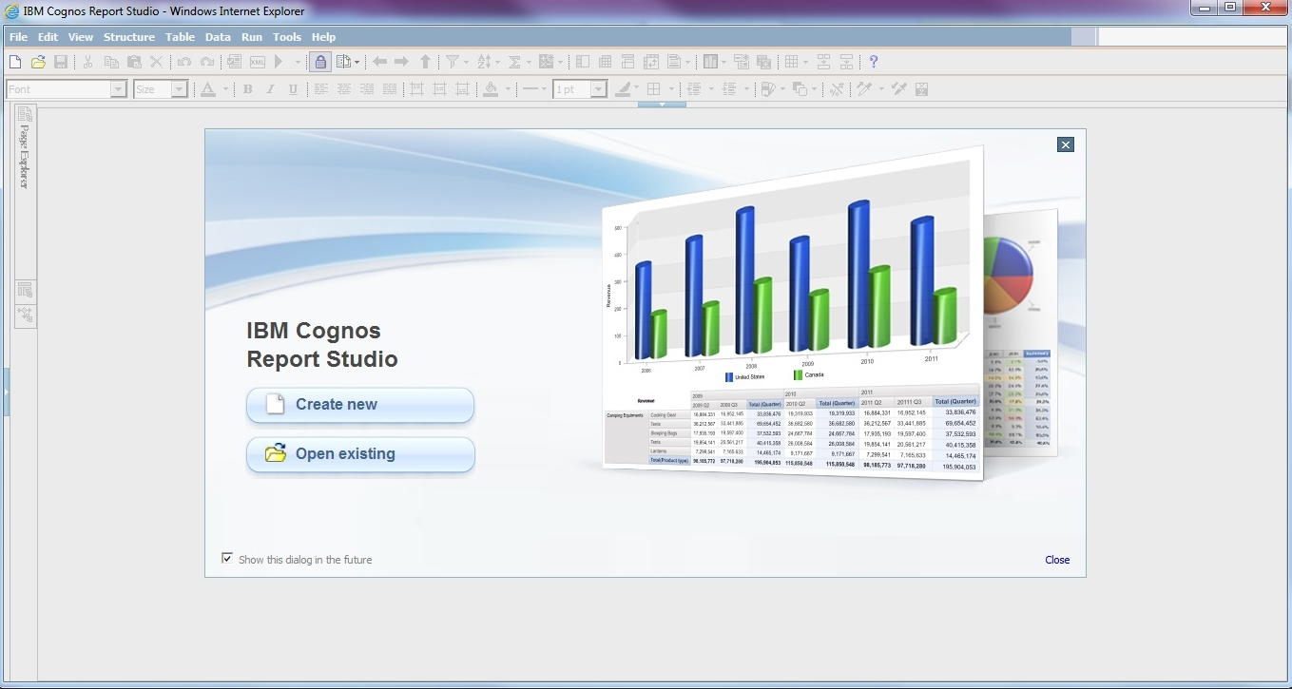

Figure 3 Report Studio welcome page

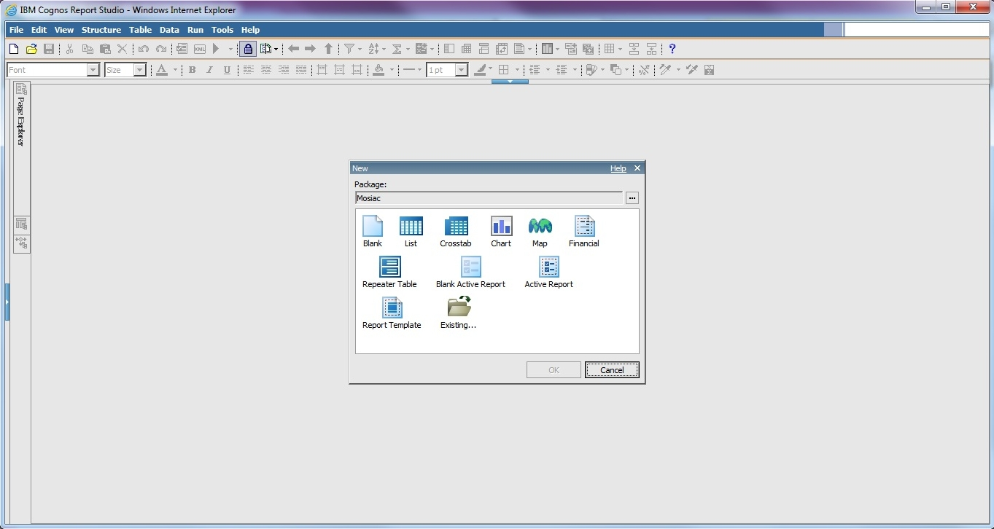

Figure 4 Select a template

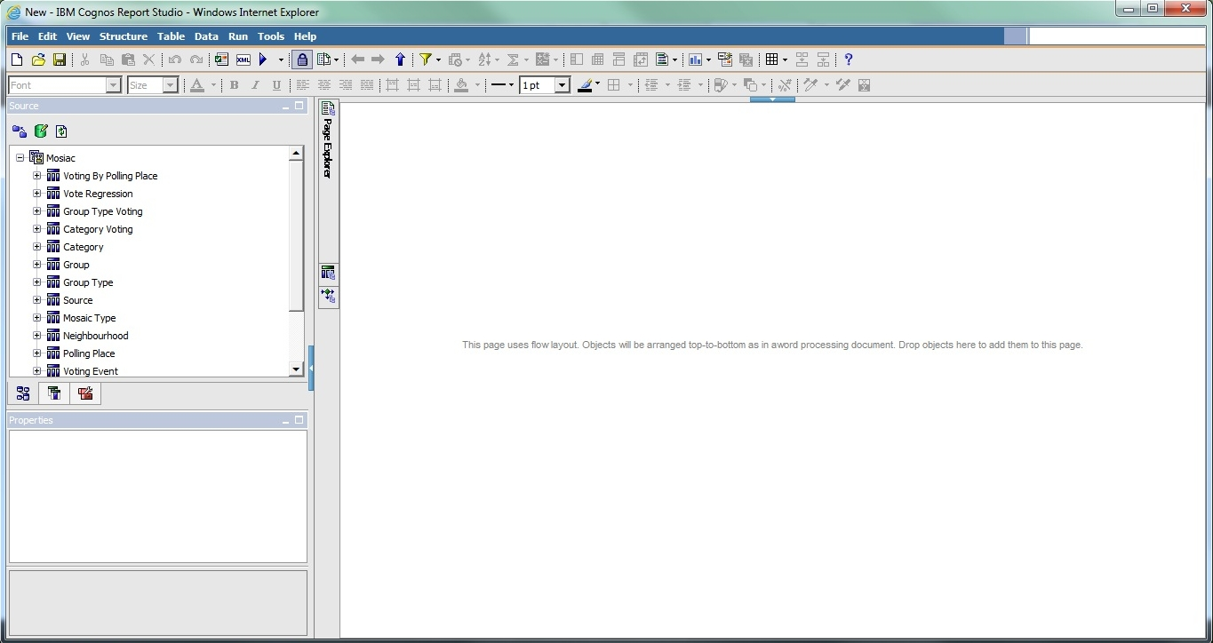

Figure 5 Blank template, Mosaic data loaded

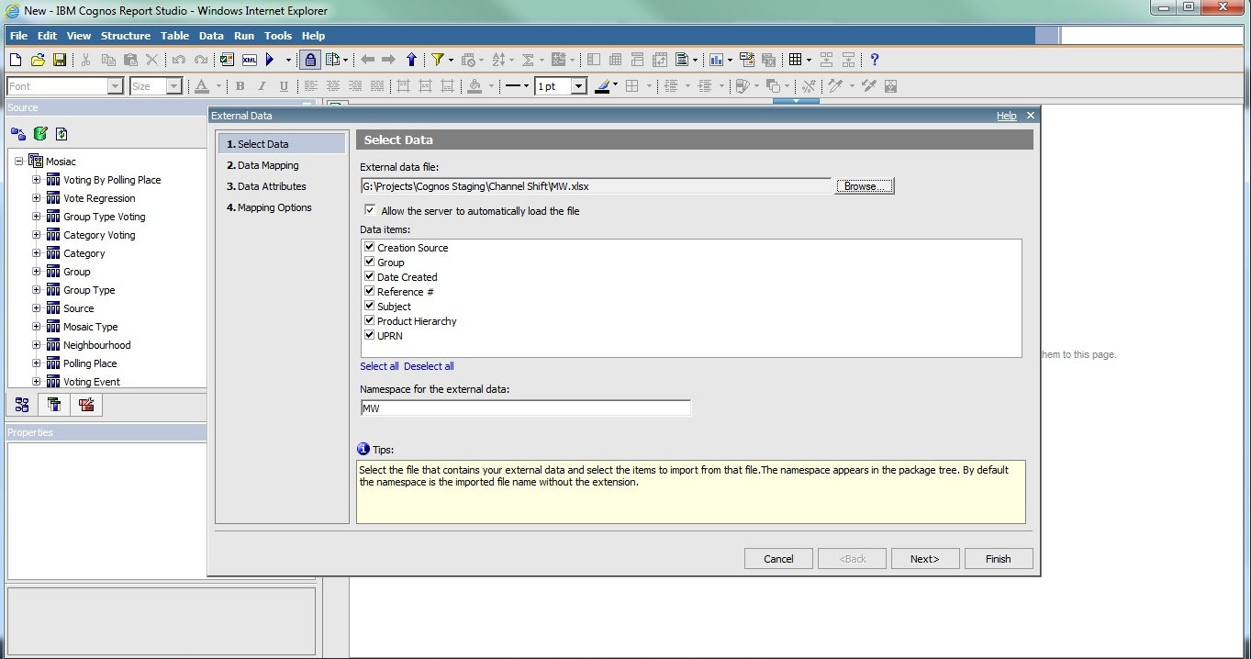

Figure 6 Importing CRM data into Report Studio with Mosaic loaded

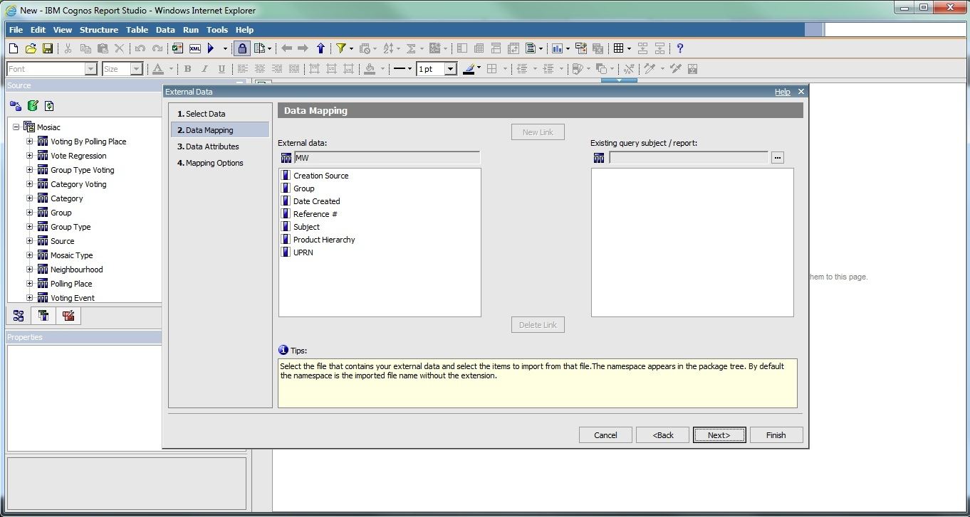

Figure 7 Importing CRM data to Report Studio, Mosaic loaded, second step - link problem

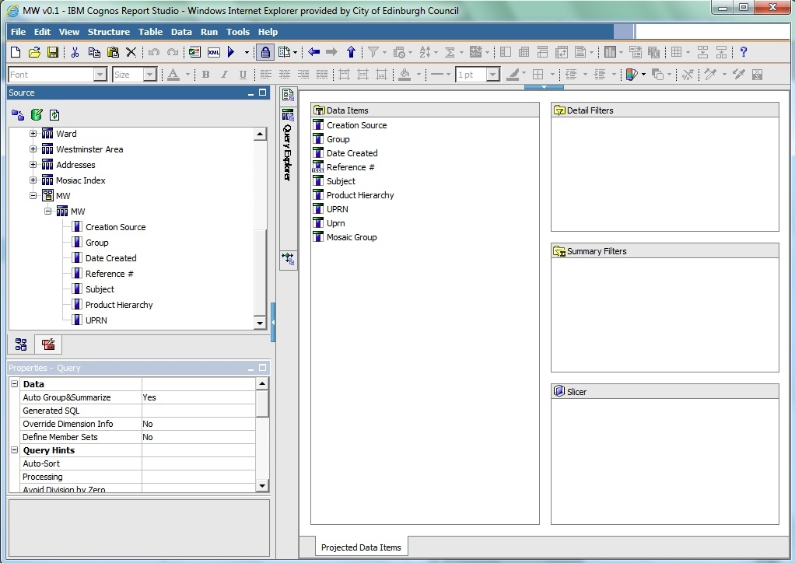

Figure 8 Creating query

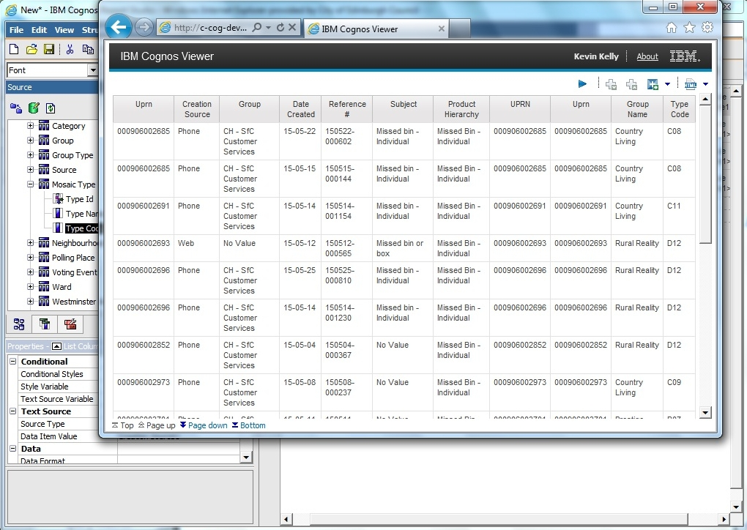

Figure 9 First report - no analysis, plain CRM data

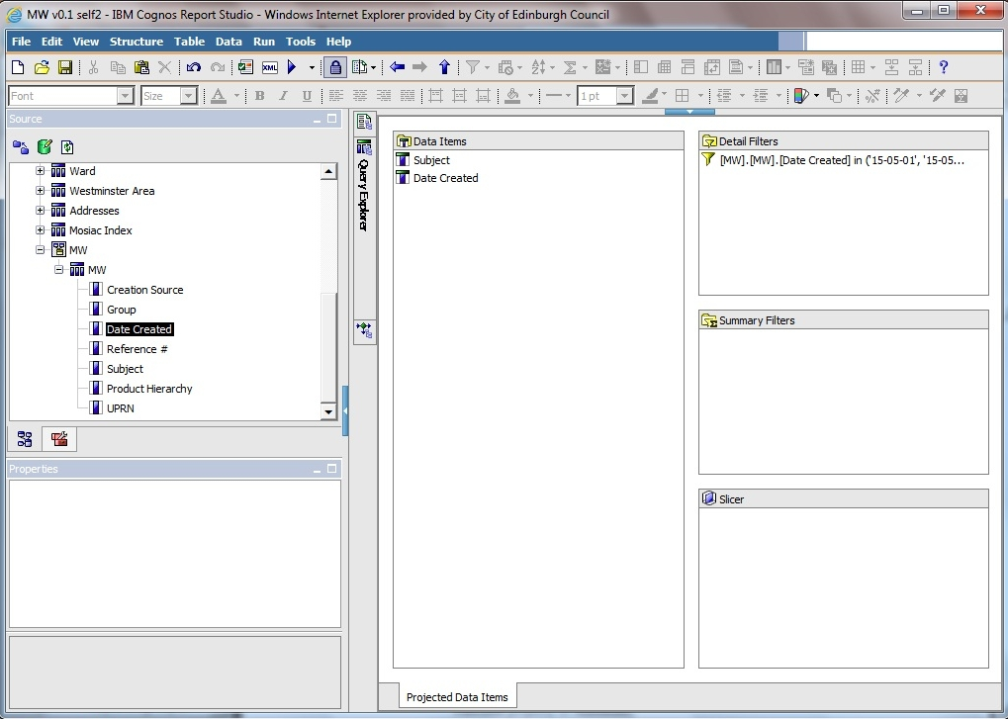

Figure 10 second query

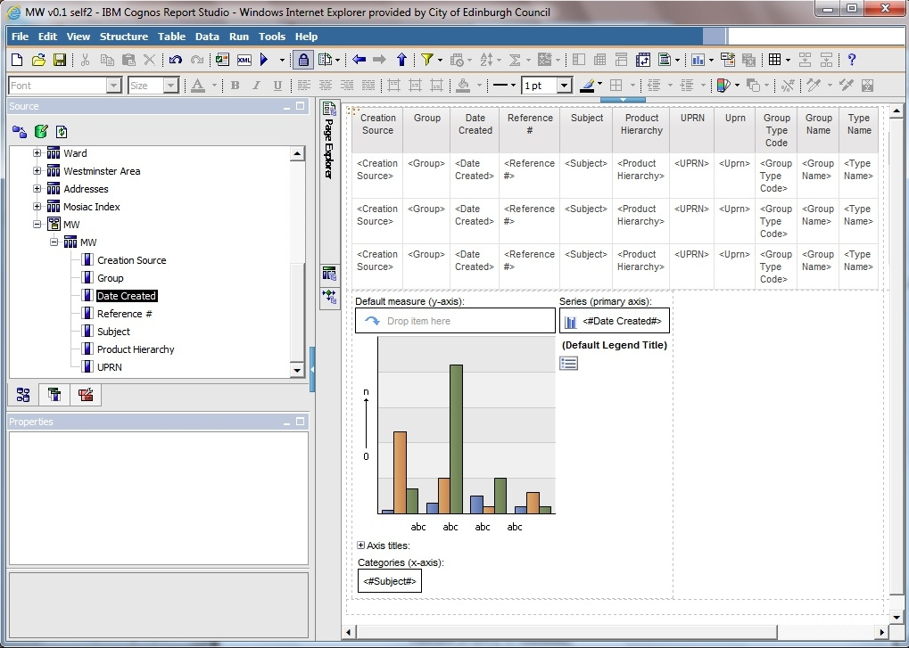

Figure 11 page layout

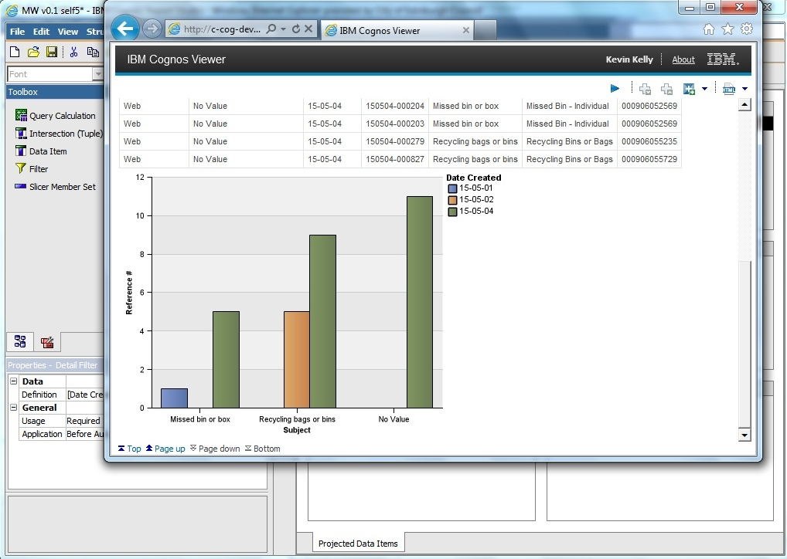

Figure 12 first chart

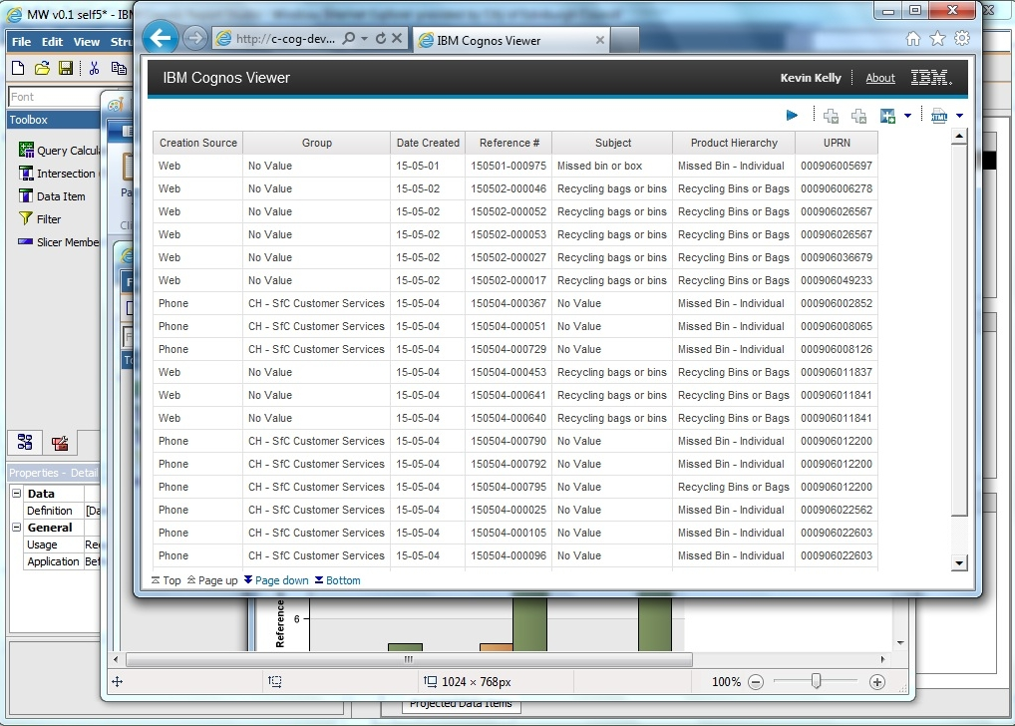

Figure 13 first chart - data to confirm chart is valid

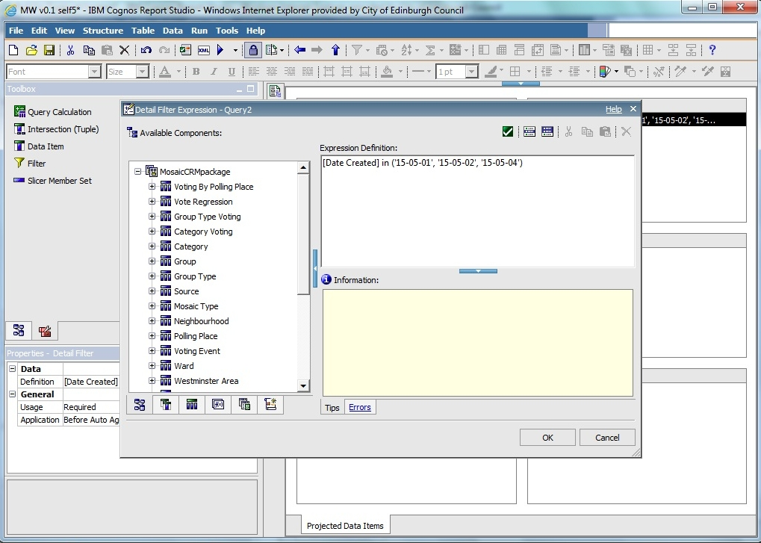

Figure 14 first chart - date filter

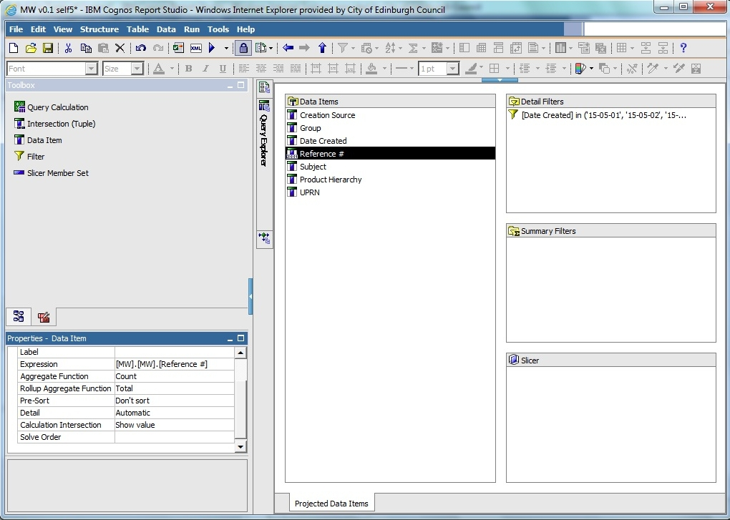

Figure 15 first chart - count total

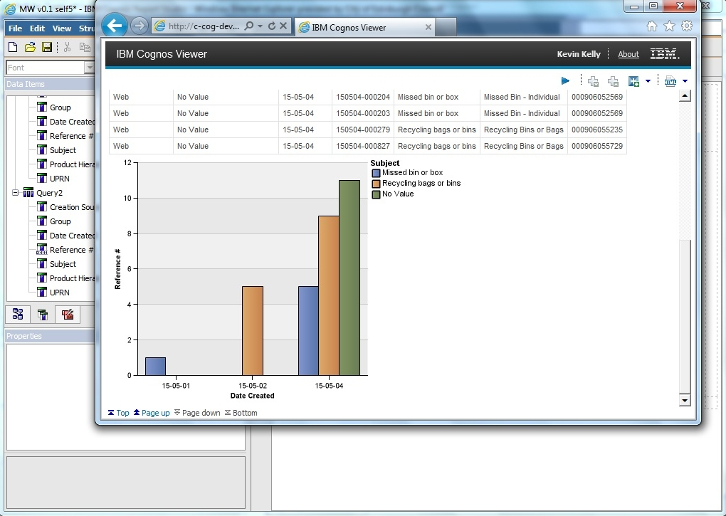

Figure 16 first chart - other dimension

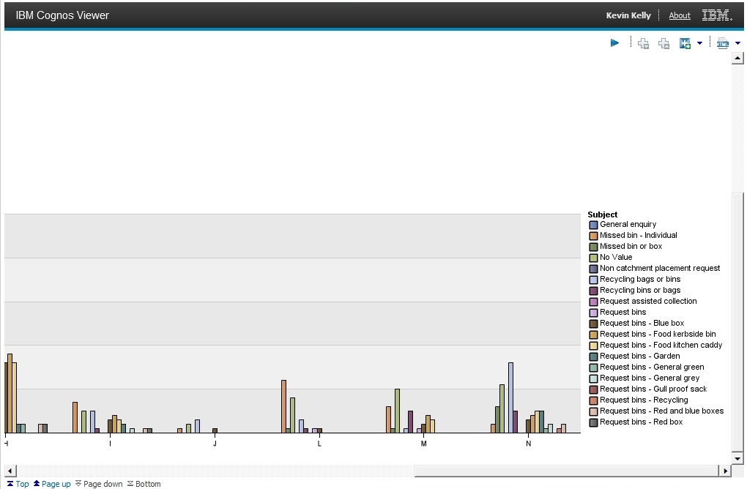

Figure 17 second chart – group category, all subjects, entire May, zoom in to legend

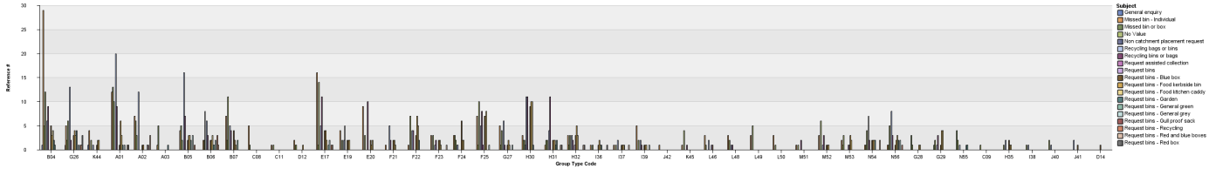

Figure 18 third chart - group code, all subjects

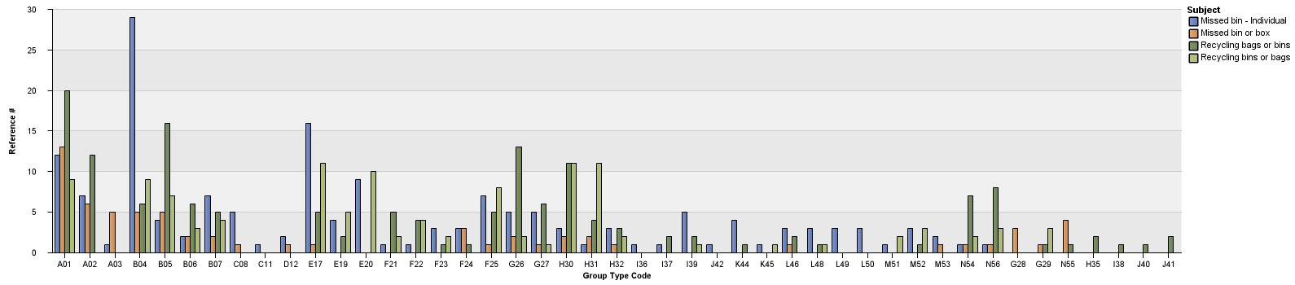

Figure 19 fourth chart - group code, missed bins, recycling bags (4 categories)

### Problems

#### Linking problem

IBM cognos link problem:

1. welcome page

2. Launch the "Report Studio" app from the list menu on the right

3. Select the Mosaic package

4. Start a new report

5. Select the type of report

We used IBM Cognos Report Studio. There was a package already created containing Mosaic data. There are different packages (see prtscrn). they can also be launched from the web interface (My folders, Public folders). It's just a different way of launching it.

We were trying to import data using Manage External Data and create links between the two. The package is not overwritten, there is another copy created containing Mosaic and CRM. Administrator sets the limit for the number of possible packages created (ask Kevin about the number, it was created by the 3rd party administartor).

https://www-304.ibm.com/support/knowledgecenter/#!/SSEP7J_10.2.2/com.ibm.swg.ba.cognos.ug_cr_rptstd.10.2.2.doc/c_rs_cwa_mng_ext_dta.html

the limit of 20000 entries is not Concil specific it's actually a limit on Cognos, source: https://www-304.ibm.com/support/knowledgecenter/#!/SSEP7J_10.2.2/com.ibm.swg.ba.cognos.ug_cr_rptstd.10.2.2.doc/c_prep_ext_data.html%23prep_ext_data

website with the solution:

https://www-304.ibm.com/support/knowledgecenter/#!/SSEP7J_10.2.2/com.ibm.swg.ba.cognos.ug_cr_rptstd.10.2.2.doc/t_id_rs_persdat_161mapdata.html%23id_rs_persdat_161MapData

#### Other problems

Problems to solve:

- when I work on a query and put a filter on data, generate report, save file, everything works fine. Then I use the same file to work on another report and start from removing the filter - when I run the report then the dates are still filtered.

- duplicate fields in CRM data ('UPRN', 'second UPRN', 'UPRN 2')

- what's the difference between 'subject' and 'product hierarchy'?

- duplicate values in field 'subject' ('Recycling bins or bags', 'Recycling bags or bins'). It's not that one value is not used and the other is. There are entries all throughout May for both.

## Work undertaken

Description of what I did, code, screenshots

Final stage (second iteration):

1. Analyze the CRM data set, extract the data I'm intersted in

2. Create a package in IBM Cognos that would contain CRM and Mosaic

3. Create queries for the data analysis

4. Create visualisations

5. Conduct user studies to confirm some of the assumptions

6. Create recommendations/suggestions

# Analysis or Evaluation

results and their critical analysis should be reported, whether the results conform to expectations or otherwise and how they compare with other related work. Where appropriate evaluation of the work against the original objectives should be presented.

# Conclusion

# Bibliography

Baars, H. & Kemper, H.-G., 2008. Management Support with Structured and Unstructured Data—An Integrated Business Intelligence Framework. *Information Systems Management*, 25(2), pp.132–148.